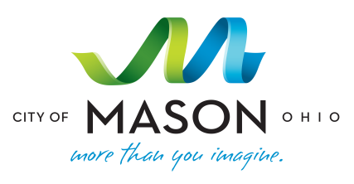
Mason Municipal Center
6000 Mason Montgomery Road
Mason, Ohio 45040
513.229.8500
FACILITY USE REQUEST FORM
Thank you for your interest in using City of Mason public meeting space. Maintaining a safe environment for the residents and businesses of Mason is a top priority. For your safety, the City has established a policy for room usage and rooms are monitored and recorded. We ask that everyone using a meeting room review the policy as violations of the policy can lead to the denial of future meeting room requests and forfeiture of security deposit. City of Mason public meeting rooms are intended to provide occasional meeting space for a variety of groups conducting organizational business. While the City attempts to maximize facility use, it is recommended that organizations not rely on consistent and frequent use of these facilities. Meeting rooms in the Municipal Center are a wonderful community asset. We encourage the use of the rooms in a manner that is safe for all patrons to enjoy.
Name:
Address:
Phone: Email:
Sponsoring Organization:
Organization Address:
Date(s) Requested: Room Requested:
Time of the Event (including set up): to Approximate Attendance:
Brief Description of Event/Activity:

Please review the questions below and check all that apply.
- Organization Type:
- City Sponsored Community Service Organization
- Private Organization Commercial Business

- Is your organization a non-profit? Yes No
If checked yes, please provide relevant information or literature supporting your non-profit status.
- Will children under 12 years of age be present? Yes No

- Will food or refreshments be served? Yes No
- Will you be attending the meeting? Yes No
I have read and accept the terms, rules and guidelines for use of public meeting space provided by the City of Mason.
Signature: Date:

