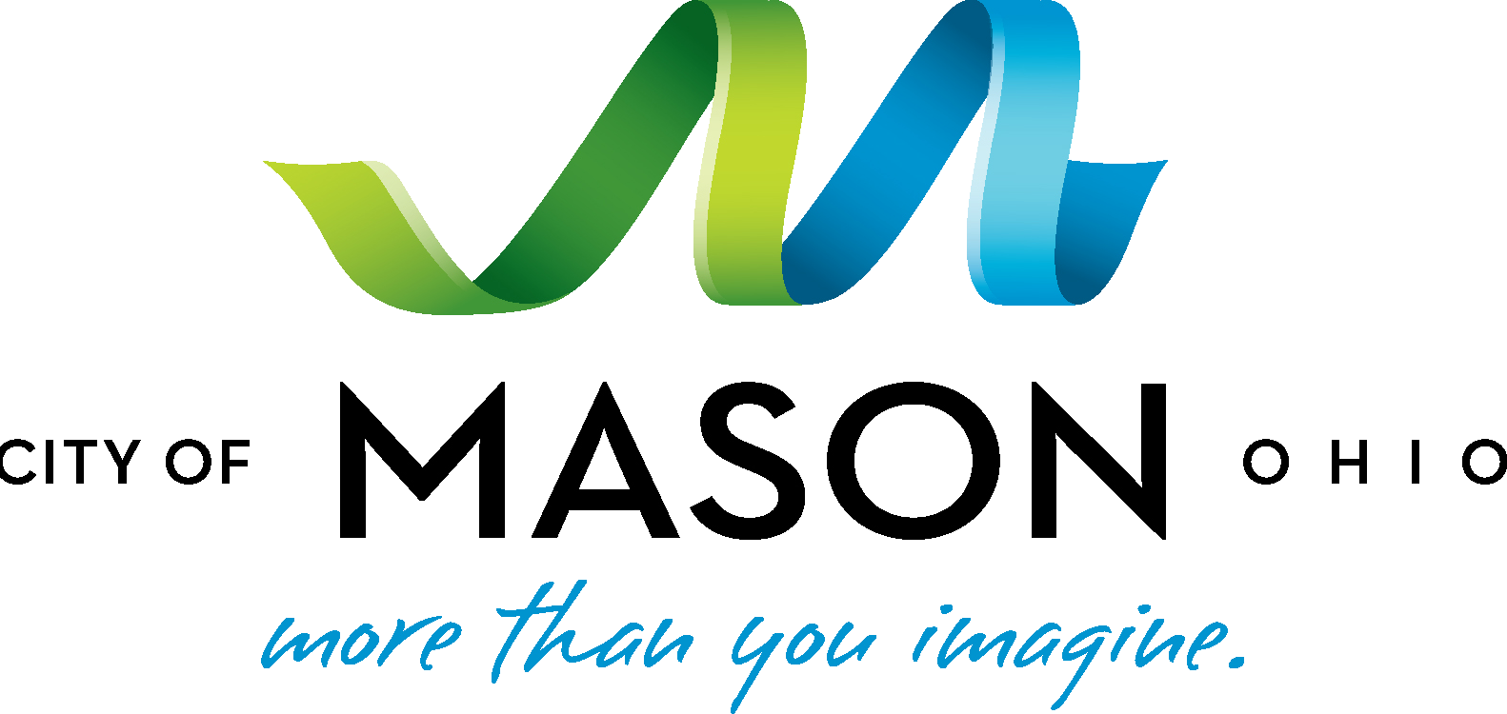

Fact Sheet: P&G Beauty Innovation Center to be Built in Mason, Ohio Breaking News, Tuesday, March 17, 2015
P&G announced today it has selected Mason, Ohio, as the home for a new Beauty Innovation Center at its existing business center campus on Mason-Montgomery Road. This will involve the relocation of P&G research and development staff from their current home at Sharon Woods Innovation Center in Blue Ash. This move will bring the whole Cincinnati-based Beauty technical community together in a creative, dynamic environment that will drive capability and inspire innovation for decades to come. This also means the company’s Beauty and Health technical communities will be at the same site, giving P&G a technical center of deep and broad expertise. Currently, 1,150 P&G employees and 200 contractors work at the Sharon Woods facility. The move to Mason will occur in the 2018/2019 timeframe.

Key Facts
- P&G said The City of Blue Ash is a hugely valued partner to the company, and will be working closely with them on the sale of the Sharon Woods facility.
- This is a significant development in Mason’s strategy to grow its bioscience and biohealth cluster, given P&G’s reputation and expertise in beauty innovation.
- The space vacated by the divestiture of P&G’s Pet Care business will be utilized for the center along with major new construction.
- Preliminary work will begin next month with new construction kicking off this summer. Plans are still being finalized, but the new facility is expected to be at least a $300 million investment to create approximately 500,000 square feet of new space.
- The Beauty Care Innovation center will house top P&G researchers, scientists, inventors, consumer experts, and more in a state of the art facility with labs, pilot plants, and spaces to get feedback from consumers on new P&G beauty products.
- The City of Mason and Mason Port Authority agreed to provide financial support for the move only in the event P&G was unable to expand in its current Blue Ash location. The financial incentives, which were not a driver for this decision, include traditional economic resources, such as a Community Reinvestment Area (CRA) incentive and capital lease advantages, as well as an Economic Reuse Grant to support marketing of the current Sharon Woods facility.
- The Mason Business Center Campus was built with an eye toward long-term investment and city leaders with Warren County and the Warren County Transportation Improvement District (WCTID) have made intentional continued investments in infrastructure to position the area for a project of this size. The state recently awarded $16.4 million to the WCTID to fund planned improvements at Western Row Road. Work is also being completed at the Fields Ertel Mason- Montgomery/I-71 interchange.

Quotes

- “P&G is a significant business partner of the City of Mason, and we have worked closely with them to develop a competitive structure for this new investment. As we continue to grow our biosciences cluster in Mason, P&G’s investment is a catalyst for future development, growth and talent attraction. P&G has unique national and international expertise in consumer understanding and bioscience innovation that will benefit our community’s mutual commitment to health, wellness, innovation and public/private partnership. Mason leadership and economic development team understands the business mindset of a Fortune 100 company like P&G and appreciates strong regional partners like the Mason School District and Warren County who work collaboratively with us to support their growth and development.”
City of Mason Mayor David F. Nichols

- “This decision is rooted in our need to drive innovation that is meaningful to consumers here and around the world. This center will drive our beauty business and inspire innovation for decades to come.”

P&G Spokesman, Bryan
McCleary

Contacts

Bryan McCleary, P&G Mimi Rasor, Mason
McCleary.be@pg.com mimi@rasormarketing.com
513-983-3517 513-910-8385

